Time Value of Money and Basics of Capital Budgeting
Pearland Medical Center is considering two proposed capital investment opportunities, Project A and Project B. Each project requires a net investment of $100,000. The cost of capital for each project is 12 percent. The projects’ expected cash revenues are:
Year | Project A | Project B
0 | ($100,000) | ($100,000)
1 | $62,500 | $32,625
2 | $30,000 | $32,625
3 | $28,000 | $32,625
4 | $10,000 | $32,625
Calculate each project’s payback period, net present value, and internal rate of return. Explain which project is financially acceptable.

Project B is more financially adaptable because it pays the investment back sooner and also offers a much larger rate of return.

Project A: Payback Period



Project A: NPV


Project: A Internal Rate of Return
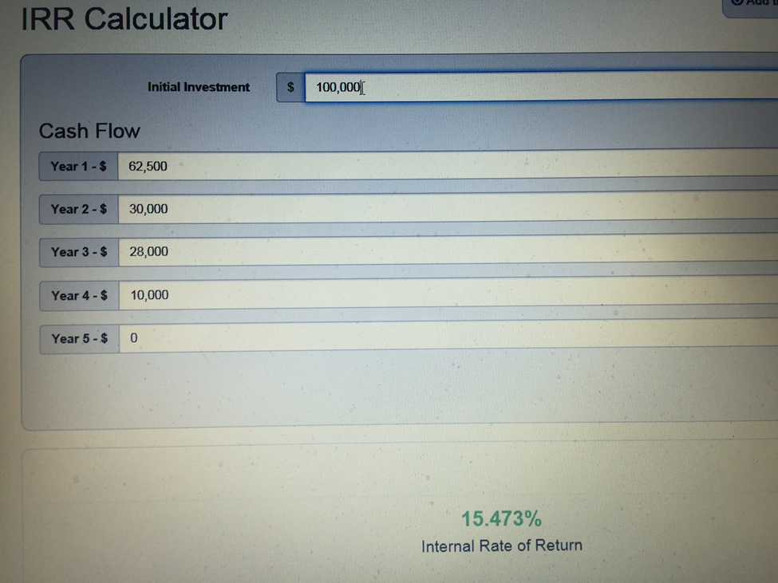

Project B: Payback Period
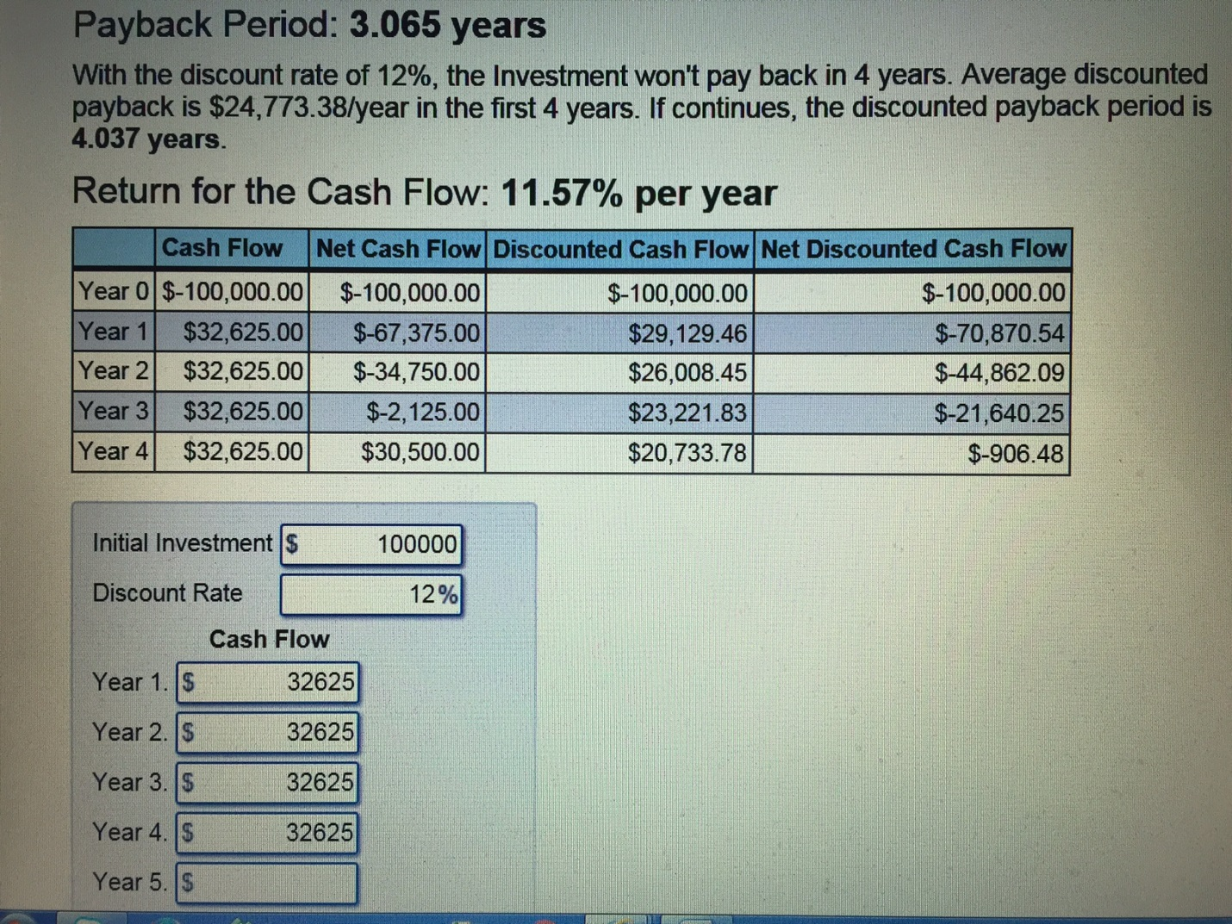

Project B: NPV 

Project: B Internal Rate of Return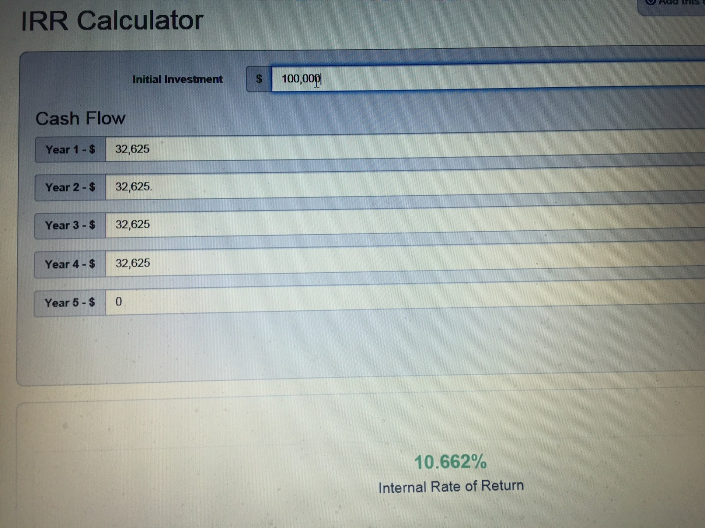

2. Avery, Flaherty, and Rhee (2011) noted that when choosing a capital budgeting decision tool, academics recommend NPV as the primary approach followed by IRR. What are the advantages and disadvantages of NPV and IRR methods in regards to profitability analysis in evaluating investment decisions?
Advantages to NPV and IRR :
Some of the advantages with NPV method is it is a direct measure of the dollar contribution. Where the advantages of IRR is this shows the return on the money originally invested.
Disadvantages to NPV and IRR:
Disadvantages to NPV method is the project size is not measured.
The disadvantages of IRR is sometimes it gives you conflicting answers compared to NPV. Another problem is the multiple IRR problem occurs when the cash flows in a projects lifetime are negative and losses our occurring
With the IRR method, the disadvantage is that, at times, it can give you conflicting answers when compared to NPV for mutually exclusive projects. Another problem is if the company is operating in the negative and needs to invest more working capital and hasn’t yet. This is called non-normal cash flow and can give off multiple IRR’s. Bottom line is cash flow timing and project sizes produce conflicting results in the NPV and IRR methods. Both methods are designed to either accept or reject the project often with very different outcomes

3. Why are firms using the payback period method as a primarily decision-making tool?
begins.
Many firms choose to use the payback method as the primary decision-making tool because it allows them to know how long their money will be tied up before their original investment is returned in their current investment begins to show profitability. This method allows them to know exactly what to expect as far as the timeline in tying up their capital and the timeline determining when profitability starts in the investment. In business understanding when your capital can be accessed and when you’re investment becomes profitable is very beneficial.

